Exercise 4

Applications of Data Analysis

Marco Willgren 502606 [mahewi@utu.fi](mailto:mahewi@utu.fi)

Jarno Vuorenmaa 503618 [jkivuo@utu.fi](mailto:jkivuo@utu.fi)

# Data preprocessing and creating distance matrix

Data was given in three csv-files. We read the input data in *x*, output data in *y* and coordinates in *z*. Also the input data is standardized and stored into *stdX*.

basepath = os.path.dirname(__file__)

inputpath = os.path.abspath(os.path.join(basepath, "Data4/INPUT.csv"))

outputpath = os.path.abspath(os.path.join(basepath, "Data4/OUTPUT.csv"))

coordinatespath = os.path.abspath(os.path.join(basepath, "Data4/COORDINATES.csv"))

x = np.genfromtxt(inputpath, delimiter=',')

y = np.genfromtxt(outputpath, delimiter=',')

z = np.genfromtxt(coordinatespath, delimiter=',')

xArr = np.asarray(x)

stdX = (xArr - xArr.mean()) / xArr.std()

Distances between every pair of points is stored into a distance matrix. Mij is the euclidean distance between *i*th and *j*th point in data. If i=j, the Mij is set to -1.

def **calculateDistanceMatrix**():

distanceMatrix = []

for i in range(len(z)):

xAxis = []

for j in range(len(z)):

if i == j:

xAxis.append(-1.0)

else:

xAxis.append(ssd.euclidean(z[i], z[j]))

distanceMatrix.append(xAxis)

return distanceMatrix

# Finding out values in deadzone

The Method *calculateDeadZone* finds the 10 nearest points (where the distance is larger or equal to 0.0) for every data point and sets the distance to those points as -1. Thus our implementation of leave-on-out cross-validation ignores those points (see below).

def **calculateDeadZone**(matrix):

for i in range(len(matrix)):

xAxis = matrix[i]

for _ in range(10):

minIndex = xAxis.index(min(filter(lambda x:x>=0.0, xAxis)))

xAxis[minIndex] = -1.0

return matrix

# Calculating 5-nearest-neighbor and predicting label

The distance between two features is calculated only if the Mij is larger or equals with 0. This limitation is done because, we need to leave the test instance out of calculation and also we need to ignore features that are in the deadzone. The distance of a feature with itself and the distances to the features in the deadzone are set to -1. The method returns k-nearest neighbors. The value of k is given as an argument and in this case it is 5.

def **inferNeighbors**(trainSet, testInstance, labels, k, distRow):

distances = []

for x in range(len(trainSet)):

if distRow[x] >= 0.0:

distances.append((ssd.euclidean(trainSet[x], testInstance), labels[x]))

distances.sort(key=operator.itemgetter(0))

return distances[0:k]

The predicted value for the test instance is the mean value of its neighbors' classes.

def **chooseMajorityLabel**(neighbors, k):

predictedOutcome = []

sumOfMod = 0.0

for i in range(len(neighbors)):

sumOfMod = sumOfMod + neighbors[i][1]

predictedOutcome.append(sumOfMod/k)

return predictedOutcome

# Leave-one-out Cross-validation

Leave-one-out cross-validation – method gets the number of nearest neighbors to consider and a distance matrix as its arguments. The distance matrix consists of distances between every pair of points.

The method takes every instance from the training set one by one to use as a test set and calculates the instance's neighbors. The predicted label for the test instance is calculated based on its nearest neighbors and the label is added to a list of predictions made throughout the execution of the method.

After that the c-index is calculated based on pseudo-code we got in last exercise (Third Exercise: Prediction of metal ion content from multi-parameter data).

def **LooCV**(k, distanceMatrix):

yPredictions = []

for i in range(len(stdX)):

neighbors = inferNeighbors(stdX, stdX[i], y, k, distanceMatrix[i])

yPredictions.append(chooseMajorityLabel(neighbors,k))

cIndex = calculateCIndex(yPredictions, y)

printCIndexes(cIndex)

return cIndex

# Summing all the methods

Firstly, the distance matrix is created. This matrix is used and modified during calculation. C-index is calculated for each of the dead zone radius "cases" using leave-one-out implementation of cross validation (see above) together with the pattern recognition algorithmn k(5)-nearest-neighbors). After each dead zone radius case (0,10,20…,200) the distance matrix is modified by disabling the next 10 nearest points. In the first round it disables 1-10 nearest features, in second round 11-20 nearest features and so on.

def **main**():

startTime = int(round(time.time() * 1000))

distanceMatrix = calculateDistanceMatrix()

cIndexes = []

deadZoneValues = []

for i in range(21):

print *'Leave-one-out CV with deadzone radius '* + str(i * 10) + *':'*

cIndexes.append(LooCV(5, distanceMatrix))

deadZoneValues.append(i * 10)

distanceMatrix = calculateDeadZone(distanceMatrix)

endTime = int(round(time.time() * 1000))

print *'Running time: '* + str(endTime - startTime) + *'ms'*

plotCIndexVsDeadZone(cIndexes, deadZoneValues)

All the used deadzone radius and c-indexes are plotted:

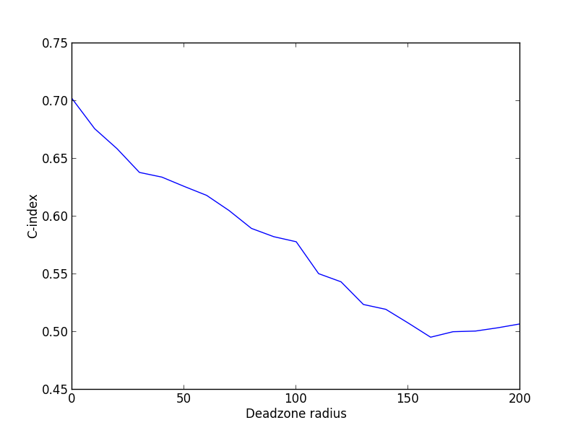

And same data as plotted above:

Leave-one-out CV with deadzone radius **0**: C-Index: 0.**701855867534**

Leave-one-out CV with deadzone radius **10**: C-Index: 0.**676058930829**

Leave-one-out CV with deadzone radius **20**: C-Index: 0.**658731830851**

Leave-one-out CV with deadzone radius **30**: C-Index: 0.**638168826969**

Leave-one-out CV with deadzone radius **40**: C-Index: 0.**634122722163**

Leave-one-out CV with deadzone radius **50**: C-Index: 0.**626040661936**

Leave-one-out CV with deadzone radius **60**: C-Index: 0.**618301230945**

Leave-one-out CV with deadzone radius **70**: C-Index: 0.**605187175657**

Leave-one-out CV with deadzone radius **80**: C-Index: 0.**589694664503**

Leave-one-out CV with deadzone radius **90**: C-Index: 0.**582504700215**

Leave-one-out CV with deadzone radius **100**: C-Index: 0.**578135914964**

Leave-one-out CV with deadzone radius **110**: C-Index: 0.**550505789349**

Leave-one-out CV with deadzone radius **120**: C-Index: 0.**543447067108**

Leave-one-out CV with deadzone radius **130**: C-Index: 0.**523801007659**

Leave-one-out CV with deadzone radius **140**: C-Index: 0.**519612461485**

Leave-one-out CV with deadzone radius **150**: C-Index: 0.**507752730185**

Leave-one-out CV with deadzone radius **160**: C-Index: 0.**495467424674**

Leave-one-out CV with deadzone radius **170**: C-Index: 0.**500218736745**

Leave-one-out CV with deadzone radius **180**: C-Index: 0.**500782202599**

Leave-one-out CV with deadzone radius **190**: C-Index: 0.**503624030384**

Leave-one-out CV with deadzone radius **200**: C-Index: 0.**507006575402**

# Code

*'''*

*Authors: Marco Willgren, 502606*

*Jarno Vuorenmaa, 503618*

*Task steps:*

*1. Implement a Leave-One-Out cross validation with deadzone radius R = 0, 10, 20, ..., 200. So you will do 21 analyses in total here.*

*Use 5-nearest neighbor as the prediction method. Remember normalization.*

*2. Calculate the C-index value for each of the deadzone radius cases.*

*3. Plot the C-index vs. Deadzone radius in a graph to visualize, how the prediction performance changes with the deadzone radius.*

*Set Y-axis to be the C-index and X-axis to be Deadzone radius*

*4. Return your implementation and the graph in a written report.*

*'''*

import os

import operator

import scipy.spatial.distance as ssd

import numpy as np

import matplotlib.pyplot as pp

import time

if __name__ == *'__main__'*:

pass

basepath = os.path.dirname(__file__)

inputpath = os.path.abspath(os.path.join(basepath, *"Data4/INPUT.csv"*))

outputpath = os.path.abspath(os.path.join(basepath, *"Data4/OUTPUT.csv"*))

coordinatespath = os.path.abspath(os.path.join(basepath, *"Data4/COORDINATES.csv"*))

x = np.genfromtxt(inputpath, delimiter=*','*)

y = np.genfromtxt(outputpath, delimiter=*','*)

z = np.genfromtxt(coordinatespath, delimiter=*','*)

xArr = np.asarray(x)

stdX = (xArr - xArr.mean()) / xArr.std()

def **calculateDistanceMatrix**():

distanceMatrix = []

for i in range(len(z)):

xAxis = []

for j in range(len(z)):

if i == j:

xAxis.append(-1.0)

else:

xAxis.append(ssd.euclidean(z[i], z[j]))

distanceMatrix.append(xAxis)

return distanceMatrix

def **calculateCIndex**(predictions, labels):

n = 0

h_sum = 0

for i in range(len(labels)):

t = labels[i]

p = predictions[i]

for j in range(i+1,len(labels)):

nt = labels[j]

np = predictions[j]

if t != nt:

n = n + 1

if (p < np and t < nt) or (p > np and t > nt):

h_sum = h_sum + 1

elif (p < np and t > nt) or (p > np and t < nt):

h_sum = h_sum + 0

elif (p == np):

h_sum = h_sum + 0.5

if n == 0:

return 0

else:

return h_sum/n

def **LooCV**(k, distanceMatrix):

yPredictions = []

for i in range(len(stdX)):

neighbors = inferNeighbors(stdX, stdX[i], y, k, distanceMatrix[i])

yPredictions.append(chooseMajorityLabel(neighbors,k))

cIndex = calculateCIndex(yPredictions, y)

printCIndexes(cIndex)

return cIndex

def **chooseMajorityLabel**(neighbors, k):

predictedOutcome = []

sumOfMod = 0.0

for i in range(len(neighbors)):

sumOfMod = sumOfMod + neighbors[i][1]

predictedOutcome.append(sumOfMod/k)

return predictedOutcome

def **inferNeighbors**(trainSet, testInstance, labels, k, distRow):

distances = []

for x in range(len(trainSet)):

if distRow[x] >= 0.0:

distances.append((ssd.euclidean(trainSet[x], testInstance), labels[x]))

distances.sort(key=operator.itemgetter(0))

return distances[0:k]

def **printCIndexes**(cIndex):

print *'C-Index: {a}'*.format(a=cIndex)

print

def **calculateDeadZone**(matrix):

for i in range(len(matrix)):

xAxis = matrix[i]

for _ in range(10):

minIndex = xAxis.index(min(filter(lambda x:x>=0.0, xAxis)))

xAxis[minIndex] = -1.0

return matrix

def **plotCIndexVsDeadZone**(cIndexes, deadZoneValues):

pp.ylabel(*'C-index'*)

pp.xlabel(*'Deadzone radius'*)

pp.plot(deadZoneValues, cIndexes)

pp.show()

def **main**():

startTime = int(round(time.time() * 1000))

distanceMatrix = calculateDistanceMatrix()

cIndexes = []

deadZoneValues = []

for i in range(21):

print *'Leave-one-out CV with deadzone radius '* + str(i * 10) + *':'*

cIndexes.append(LooCV(5, distanceMatrix))

deadZoneValues.append(i * 10)

distanceMatrix = calculateDeadZone(distanceMatrix)

endTime = int(round(time.time() * 1000))

print *'Running time: '* + str(endTime - startTime) + *'ms'*

plotCIndexVsDeadZone(cIndexes, deadZoneValues)

main()